**CIRCUIT DIAGRAM:**

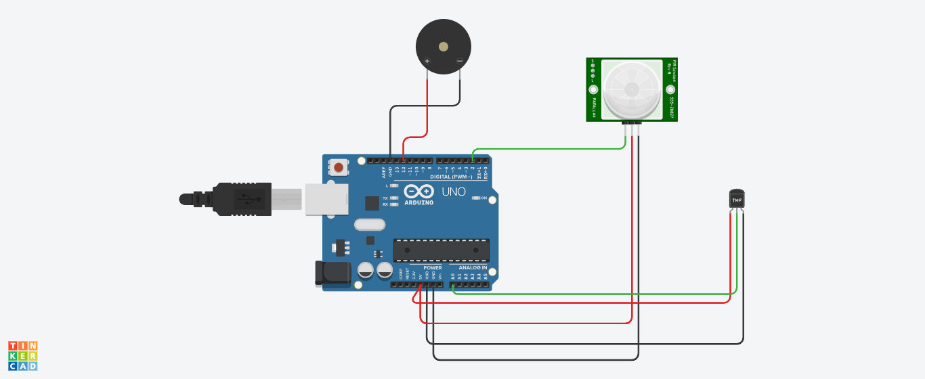

**OUTPUT:**

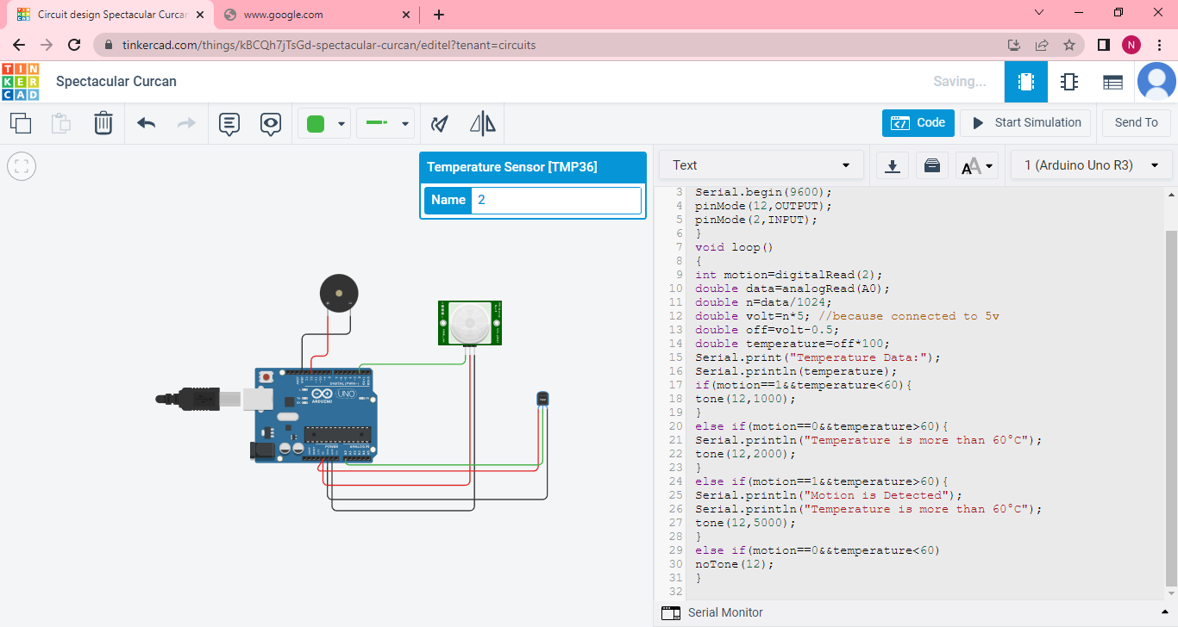

**PROGRAM**:

void setup()

{

Serial.begin(9600);

pinMode(12,OUTPUT);

pinMode(2,INPUT);

}

void loop()

{

int motion=digitalRead(2);

double data=analogRead(A0);

double n=data/1024;

double volt=n*5; //because connected to 5v

double off=volt-0.5;

double temperature=off*100;

Serial.print("Temperature Data:");

Serial.println(temperature);

if(motion==1&&temperature<60){

tone(12,1000);

}

else if(motion==0&&temperature>60){

Serial.println("Temperature is more than 60°C");

tone(12,2000);

}

else if(motion==1&&temperature>60){

Serial.println("Motion is Detected");

Serial.println("Temperature is more than 60°C");

tone(12,5000);

}

else if(motion==0&&temperature<60)

noTone(12);

}